**SYSTEL INSTITUTE OF MANAGEMENT**

**AND RESEARCH DHULE**



**A PROJECT REPORT ON**

**Spa & Academy**

**Management System**

FOR

**M.M.S.(Comp. Mgmt.)**

**SUBMITTED BY**

**Mahendra Mohan Hiyalis**

**PRN NO:-2018015400144535**

**Guided By**

**Prof.**

**K.B.C. NORTH MAHATASHTRA UNIVERSITY**

**JALGAON**

**(2022-2023)**

**SYSTEL INSTITUTE OF MANAGEMENT AND RESEARCH, DHULE**



**CERTIFICATE**

This is to certify that **Mahendra Mohan Hiyalis** student of **M.M.S.(Comt. Mgmt.)** has satisfactorily completed his project work in subject “**Spa & Academy Management System**” during the academic year 2022-2023. He has been carried out under my guidance and to the best of my knowledge and belief has not been submitted by elsewhere before.

(Project Guide) (Director)

**Guide Name Prof. Dr. H. M. Patil**

**External Examiner External Examiner**

**ACKNOWLEDGEMENT**

It is with great pleasure & effort that I am able to present this project report. I have tried my best to make it complete in all report. I would like to take opportunity to give my sincere thanks to those people who help me directly or indirectly during completion of this project.

I wish to express my deep sense of gratitude & sincere regards to website without whose agreement I can’t step ahead for this project.

I am specially thankful to Project Guide Prof. **Guide Name** & Director Prof. Dr. H. M. Patil for their valuable guidance & making me available with all possible resources for this Project.

Next I would like to mention me special thanks to all Faculty members of Systel Institute Of Management & Research, Dhule & all my friends who have contributed me much to complete this project.

At last but not least I would like to convey my regards to my regards to my Family members specially my parents whose emotional support is always with me during this project.

**Mahendra Mohan Hiyalis**

**INDEX**

**Chapter 1 – Introduction**

* 1. Introduction
  2. Objective
  3. Needs for computerization
  4. Scope of Project

**Chapter 2 – Proposed System**

2.1 Proposed System

2.2 Hardware and Software Specifications

2.3 Feasibility Study

**Chapter 3 – Analysis**

3.1 Data Flow Diagram

3.2 Entity relationship Diagram

3.3 UML Diagram

**Chapter 4 – System Design**

4.1 Data Dictionary

4.2 Screen Design

**Chapter 5 – Testing Procedures**

**Chapter 6 – Introduction to Software**

**Chapter 7 –Scope for the Future Enhancement**

**Chapter 8 –Conclusion & Suggestions**

**Chapter 9 – Bibliography & References**

**Chapter No 1**

**Introduction**

* 1. **Introduction to Project**

The project Spa & Academy Management System includes registration of customers , storing their details into the system. The software has the facility to give a unique id for every customer and stores the details of every customer.

The Spa & Academy Management System can be entered using a username and password. It is accessible either by an administrator. Only they can add data into the database. The data can be retrieved easily. The interface is very user-friendly. The data are well protected for personal use and makes the data processing very fast.

The Spa & Academy Management System is powerful, flexible, and easy to use and is designed and developed to delivered real conceivable benefits to spas & Academy.

The Spa & Academy Management System is designed for multispecialty salons, to cover a wide range of salons and parlor management processes. It is integrated end-to-end Spa & Salon Management System that provides relevant information across the salon to support effective decision making for customer care, spa & academy administration and critical financial accounting, in a seamless flow.

The Spa & Academy Management System is a software product suite designed to improved the quality and management of spa & academy management in the area of clinical process analysis and activity based coasting. The Spa & Academy Management System enable you to develop your organization and improve its effectiveness and quality of work. Managing the key process efficiently is critical to the success of the Spa & Academy helps you manage your processes.

**1.2 Objective of Project**

1)Define Spa & Academy.

2)Recording information about the customers that come.

3)Generating bills.

4)Recording information related to services & courses givens to customers and students/learners.

5) Keeping records of the students/learners who are enquire and interested to gating a course.

6)Keeping record of the services and courses available to them.

These are the various jobs that need to be done in a Spa & Academy by the service staff and employees. All these works are done on papers and directly.

**1.3 Need of Organization:**

We all know the importance of computerization. The world is moving ahead at lightning speed and everyone is running short of time. One always wants to get the information and perform a task he/she/they desire(s) within a short period of time and too with amount of efficiency and accuracy. The application areas for the computerization have been selected on the basis of following factors:

Minimizing the manual records kept at different locations. There will be more data integrity.

* Facilitating desired information display, very quickly, by retrieving information from users.

Facilitating various statistical information which helps in decision-making?





To reduce manual efforts in activities that involved repetitive work.

Updating and deletion of such a huge amount of data will become easier.

**1.4 Scope of Project:**

This Spa & Academy Management System can be accessed and managed by 3 types of user roles which are the Admin, Employees and user(Customer).

***Admin module:***

* + Manage user, customer.
  + Create, update, Delete services & courses.
  + Create Doctor User id and password.
  + Update, Delete customer & employee details.
  + Manage Users (customers)
  + Watch Appointment History.
  + Watch Doctor Session log

***Usermodule(Customer):***

* User (Customer) Registration.
* Book appointment.
* View appointment list and status of customers
* Cancel Appointment
* Manage own Profile
* Change Password
* View Services & courses list(Under Book appointment)

***Employee Module:***

* View employee list.
* Leave employee.
* Manage employees.

**Chapter No 2**

**Proposed System**

**2.1 Proposed System:**

To overcome the drawbacks of the current manual system, a new system has been developed in the form of software. All the data is inputted to the system through input forms. The data is then stored in tables in appropriate format.

1. Whenever it is required the data, it can be retrieved very easily as computer database are very easy to handle.
2. The software is developed using XAMMP My SQL as back end software. All the data is stored in SQL tables. For retrieval of data, various queries are used. The database formats are given in XAMMP SQL.
3. For GUI (Graphical User Interface), PHP is used as front end software.

Various forms are designed for taking inputs and for printing various reports.

1. The software offers following advantages over that of current system.
2. **Accuracy** :- An invoicing documents are printed with the help of a computer system, unless and until the input is correct, accuracy can not be suspected.
3. **Sorting**:- As MY SQL is best tool for sorting a data, sorting and storing becomes very simple and less time consuming which in turn reduces the valuable man hours, hence cutting overall costs.
4. **Reliability**:- Normally a computer system is very reliable.
5. **Environmental Friendly**:- As the computer is used for storing the data, which is stored in the form of magnetic fields, less papers are required. Less use of papers means less cutting of trees and we can say that proposed system is eco-friendly system.
6. **Leader in Market:-** As latest technologies are used in daily operations, the user can be viewed as a leader in market or user of latest technologies.

**2.2 Hardware & Software Specifications**

* **Hardware Requirement:-**

|  |  |
| --- | --- |
| **Number** | **Description** |
| **Device Name** | DESKTOP-UB8E9UM |
| **Version** | 21H2 |
| **Processor** | AMD Ryzen 3 3250U with Radeon Graphics |
| **RAM** | 8.00 GB RAM |
| **Harddisk** | 256 GB SSD |
| **Monitor** | Dell Laptop |

* **Software Requirements:**

|  |  |
| --- | --- |
| **Number** | **Description** |
| **Operating System** | Windows 11 |
| **Frontend** | PHP 5.1 |
| **Backend** | MYSQL |
| **Server** | XAMMP Server/ Apache Server |
| **Design Tools** | HTML/CSS/JavaScript |

**2.3 Feasibility Study**

Feasibility study is system life cycle following the information- gathering phase. Ihe information collection that occur during preliminary to organization. The feasibility study to.

Identify problems and unexploited opportunities in the current system.

Identify major objective for the new system.

Estimate roughly the costs of solution of user problem.

Develop rough estimate of benefits and draw backs of solution.

Obtain user and management views on modification to all the of the above.

All the above points are categorized in three distinct classes.

1). Technical Feasibility.

2). Operational Feasibility.

3). Economical Feasibility.

**Technical Feasibility**

The Technical issues raised during feasibility stage investigation are like

* Does the necessary technical support exist?
* Does the proposed system have the technical capacity told the data required to use the proposed system. The recommended. System provides the necessary hardware/software platform regarding memory capacity and speed.
* Does the proposed system adequate regardless of the number of user?
* The recommended system provides multi user environment so that more than one user can work simultaneously without getting. Bothered about speed or memory limitations.
* Are these technical granted of accuracy reliability in case of data security?

The proposed system is expected to satisfy all the above- mentioned issues.

The Software required is personal visual basic engine ver.6.0 operating system can be either window XP

**Operational Feasibility**

As per demand of the organization proposed system is beneficial only if it can be turned in to information system that will meet operating requirements of consumer management system. Simple stated this test of feasibility ask if the system will work when it is developed and installed, are their major barrier to implantation & here are questions that will help test the operational feasibility of a project. Are current business methods acceptable to the user? It' they are not users may welcome the changes that will bring about more operational and useful system. The computerized system Electrical house wiring management system developed by me, shall follows the operation factors of feasibility study.

Any operator, a newcomer will also able to handle the system after getting some necessary guidelines. Any person within an organization can operate the computerized system because it is developed to be menu driven user has to just read the option specified and operate correctly as per specification. As it is observed that all person of an organization can handle the computerized system very fluently without facing any problem.

**Economical Feasibility**

Economical feasibility is used to evaluate the effectiveness of the proposed system in terms of economical criteria.

The cost analysis or ABC analysis, is it is generally called is used to find installed economical feasibility of the project in terms of the cost installed must still be a good investment for organization. Financial benefit must be at least equal to the cost incurred the Financial & economic questions raised by analysis during the preliminary investigation are for the purpose of estimating the following.

1) The cost to conduct a full system investigation.

2)The cost of hardware and software for the class of application being considered. 3)One of the benefits is that staff itself handles the proposed system. So no manpower cost is incurred. 4)The operating cost incurred is the stationary, which is negligible as compared to the benefit offered by the proposed as compared to the benefit offered by the proposed system.

**Chapter No 3**

**System Analysis**

**3.1 Data Flow Diagram:-**

**A data flow diagram:-**

A data now diagram (DFD) is a graphical representation of the "flow" of data through an information system, modeling its process aspects. A DFD is often used as a preliminary step to create an overview of the system without going into great detail, which can later be elaborated.

Customer Management

Course Bill Report

Course Bill

Service Report

Employee Report

Customer Report

Course Enquiry Report

Bill Report

Appointment Report

Course Report

Course Enquiry Management

Appointment Management

Bill Management

Service Management

Course Management

Employee Management

**Entity Relationship Diagram:-**

Add services

Add course

Add Employeess

Admin

**has**

**Spa & Academy**

Offline customer

Service Bill

Course

Student

Admin (offline mode)

User from Web Page

Appointment

Course Bill

**UML Diagram:-**

UML diagram also called as use case diagram. A use case diagram is a graphic depiction of the interactions among the elements of a system. A use case is a methodology used in system analysis to identify, clarify, and organize system requirements. The actors, usually individuals involved with the system defined according to their roles.

Use case diagram of user:

**Case diagram of User and Admin:**

**Admin**

**User**

**Chapter No 4**

**System Design**

**4.1** **Data Dictionary:**

A data dictionary provides a complete documentation of all the element of system like data items, Data stores (database) and data flow. Data described in data dictionary carries the details of data type, data name, database name, data description and data characterization. Data dictionary covers the whole organization or a database.

Data dictionary is only collection of data element definition. Entries in a data dictionary include the name of the data item and attributes. Data dictionary has been proposed a formal grammar for describing the contents of the definition of all data mentioned in the data flow diagram. In process specification, composite data is defined in terms of the meaning each of the values that it can assume.

**Database Design:**

A database design is a collection of stored data organized in such a way that the data requirements are satisfied by the database. The general objective is to make information access easy, quick, inexpensive and flexible for the user. There are also some specific objectives like controlled redundancy from failure, privacy, security and performance. A collection of relative records make up a table. To design and store data to the needed forms database tables are prepared.

Two essential settings for a database are:

* **Primary key:** - The field that is unique for all the record occurrences.
* **Foreign key:** - The field used to set relation between tables. Normalization is a technique to avoid redundancy in the tables.

**Table Name: Admin/Login:**

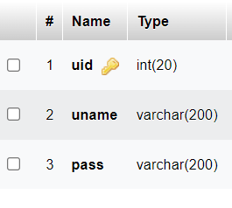

**Table Name: Appointment:**

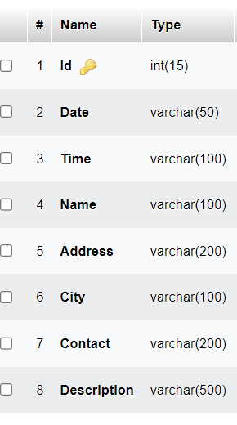

**Table Name: Customer:**

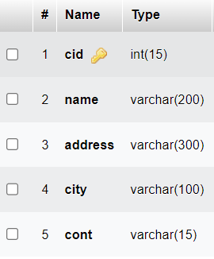

**Table Name: Course Book:**

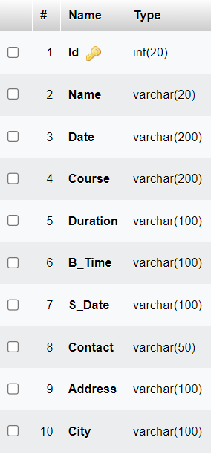

**Table Name: Course Entry:**

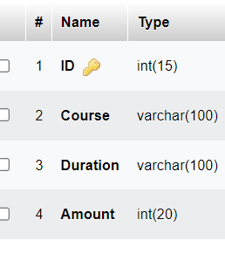

**Table Name: Service Entry:**

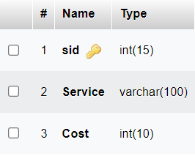

**Table Name: Employee Entry:**

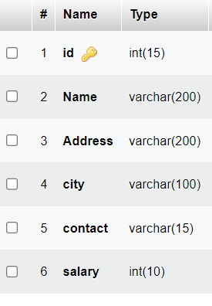

**Table Name: Service Bill:**

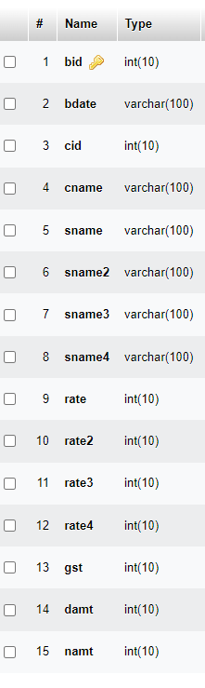

**Table Name: Course Bill:**

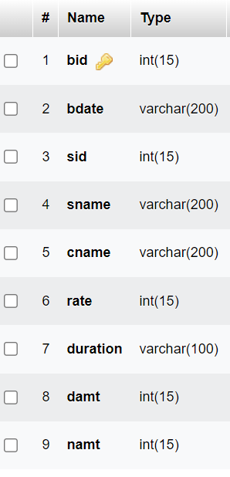

**4.2 User Interface Design:**

**Web Home Page(Client Side):**



**Admin Login:**



**Admin Home Page:**

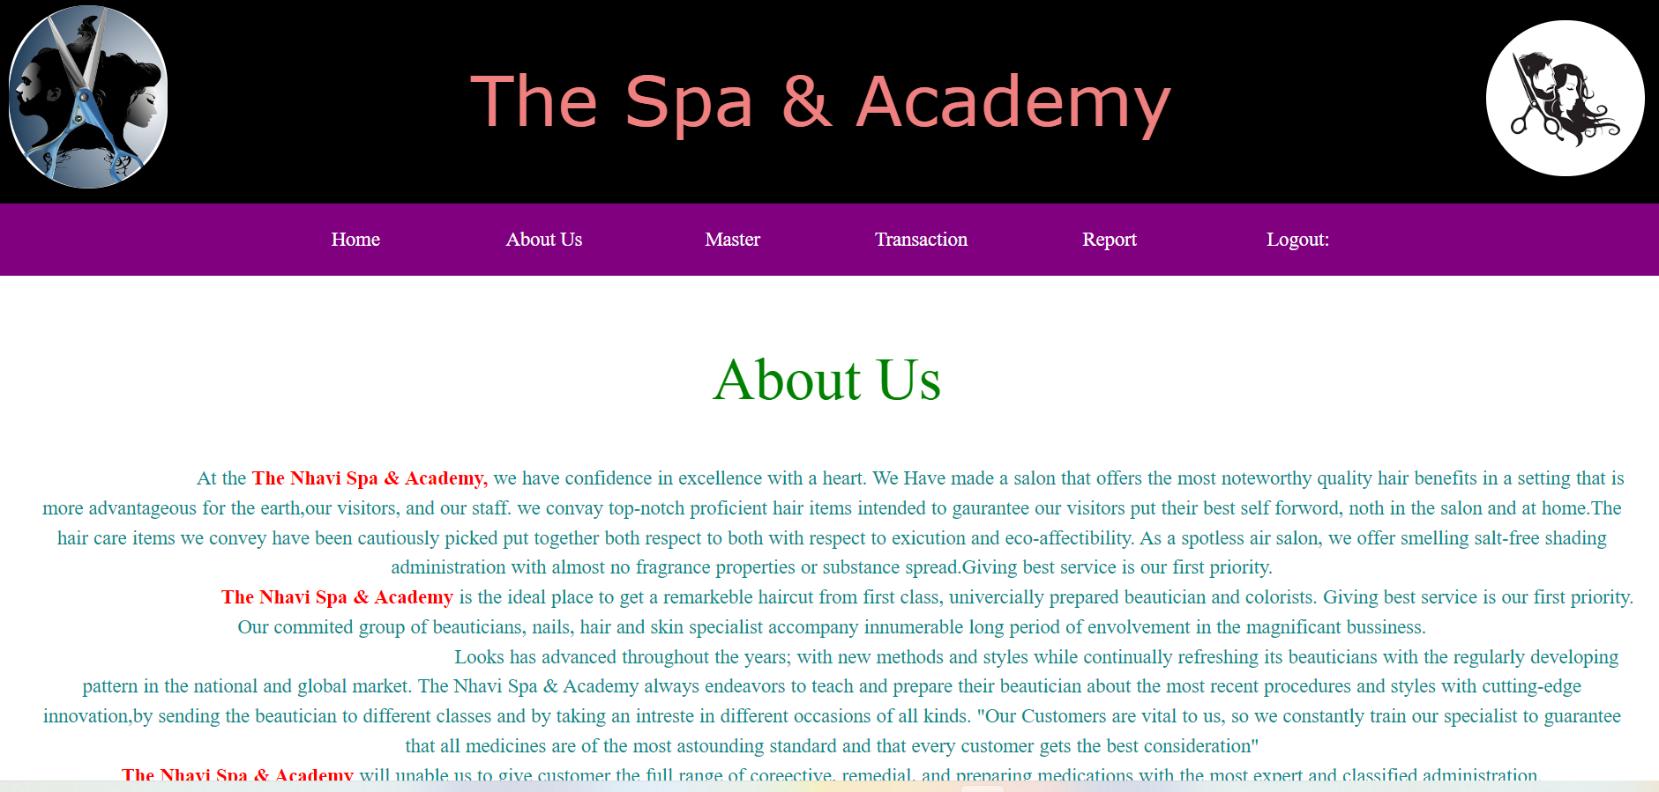

**Customer Appointment (Online):**

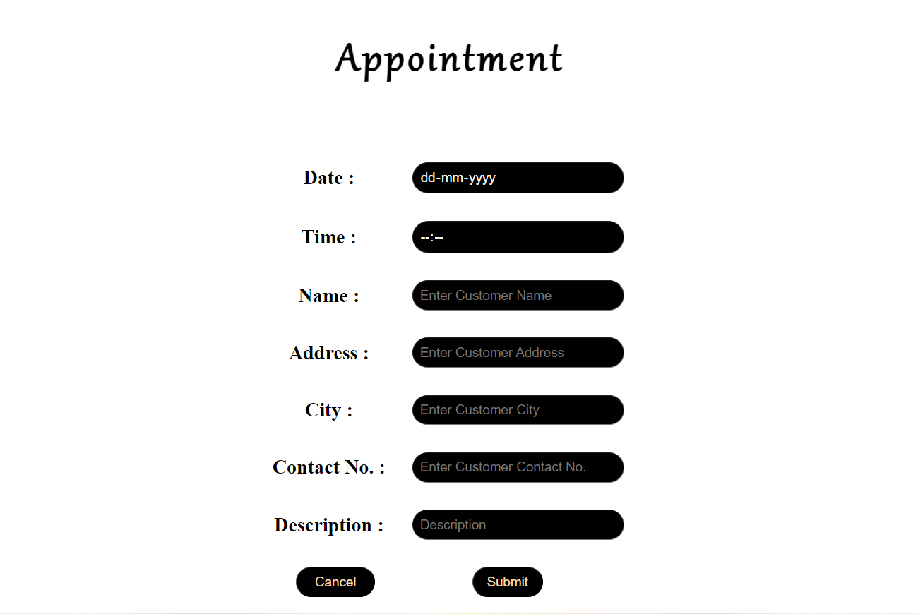

**Course Booking (Online):**

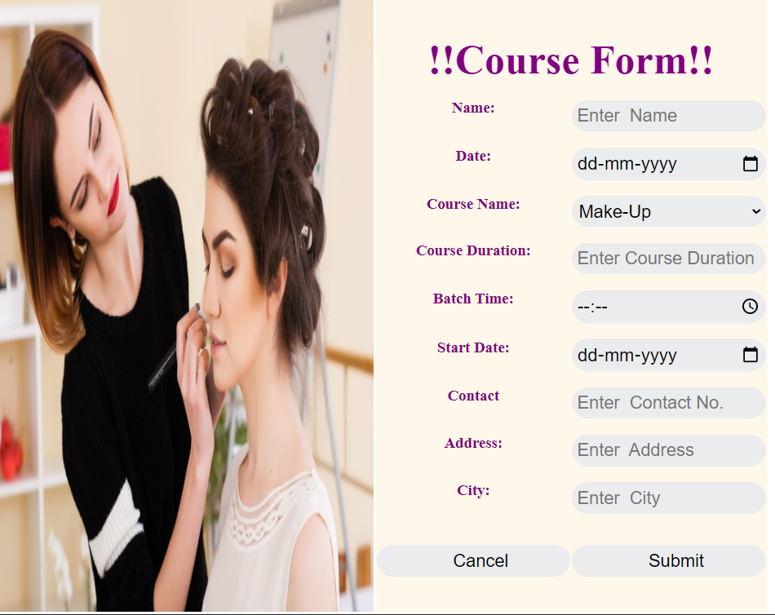

**Customer Entry(admin) Offline:-**

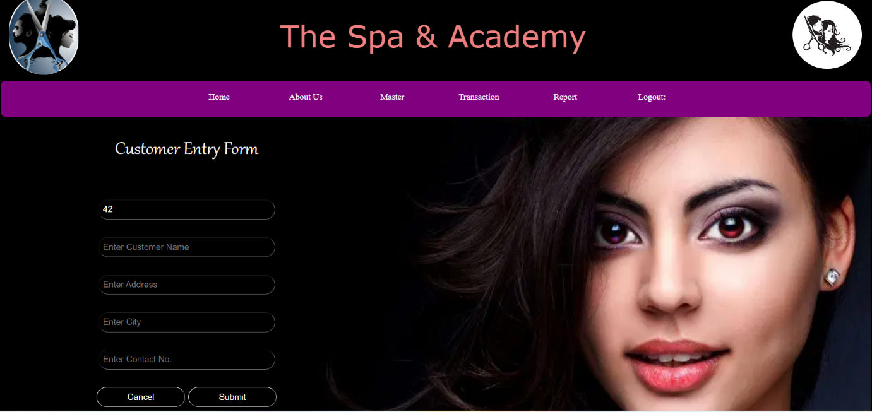

**Add Employee/ Employee Entry(Admin):-**

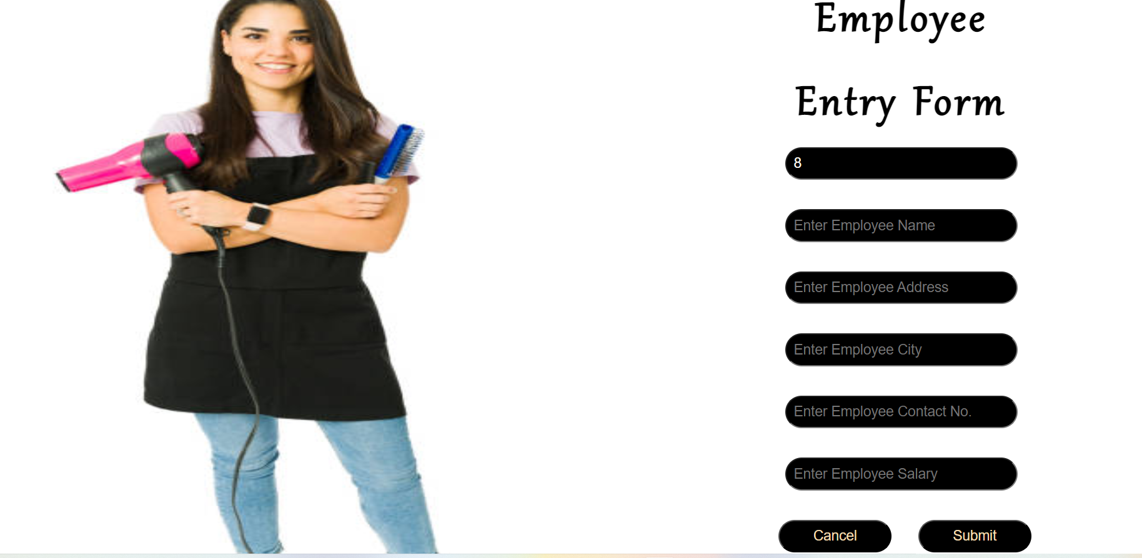

**Add Service/Service Entry :**



**Add course/Course Entry (Admin):**



**Service Billing:**

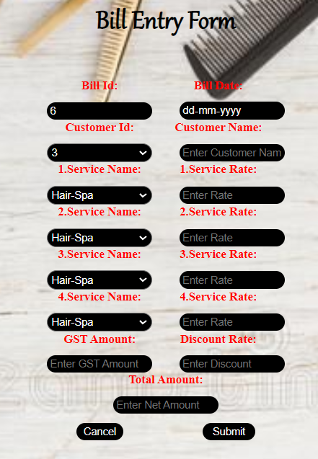

**Course Billing:**

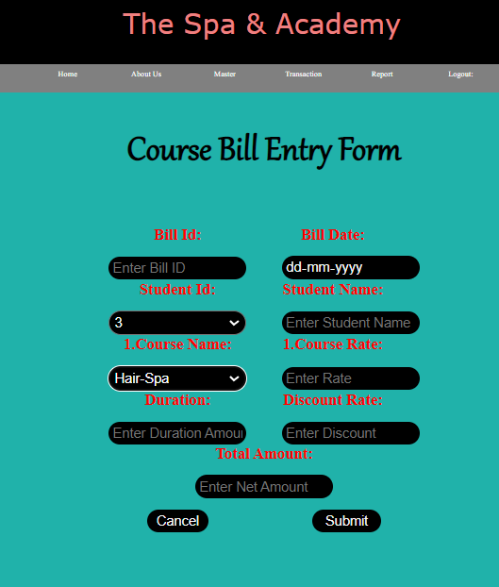

**Appointment Report:**

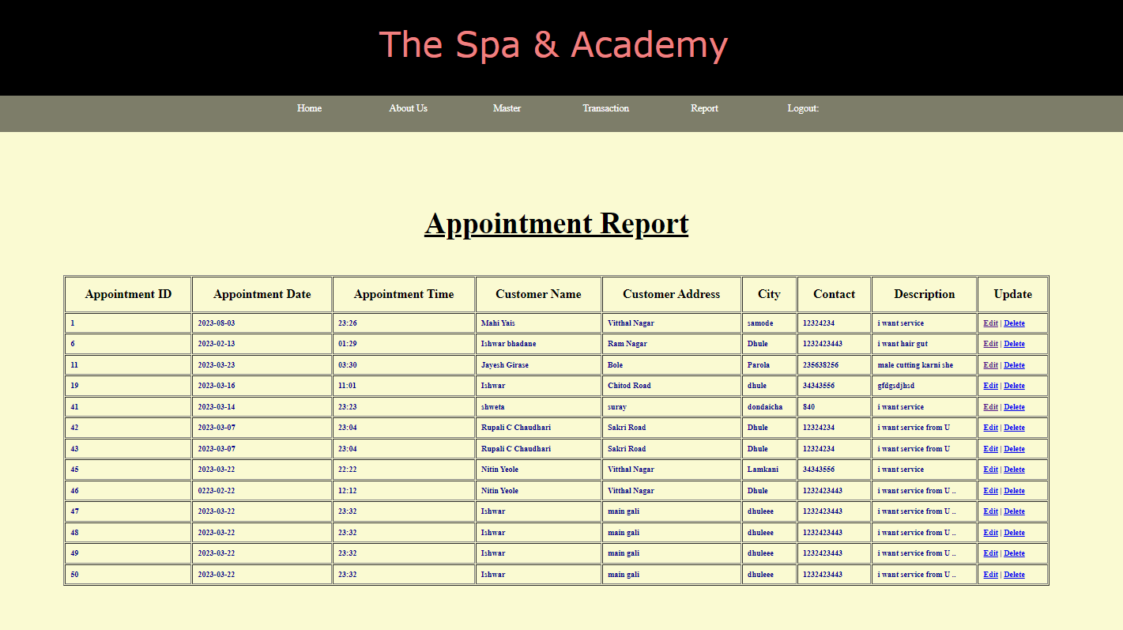

**Customer Report:**

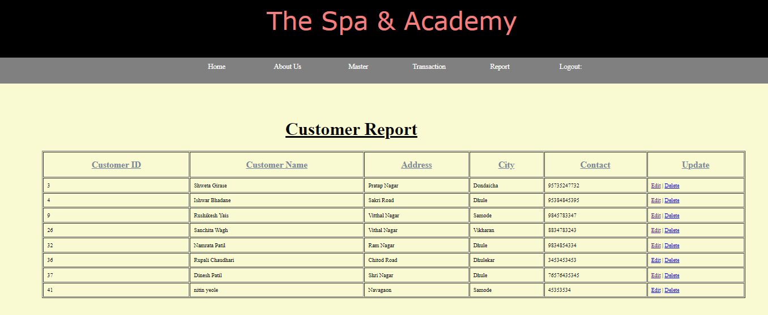

**Employee Report:**

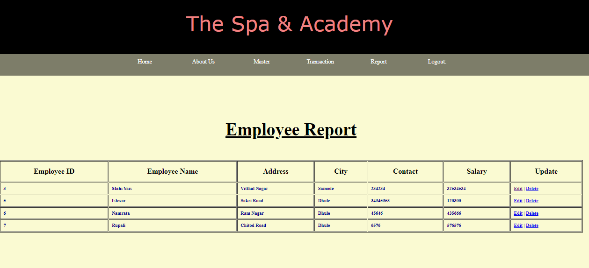

**Service Report:**

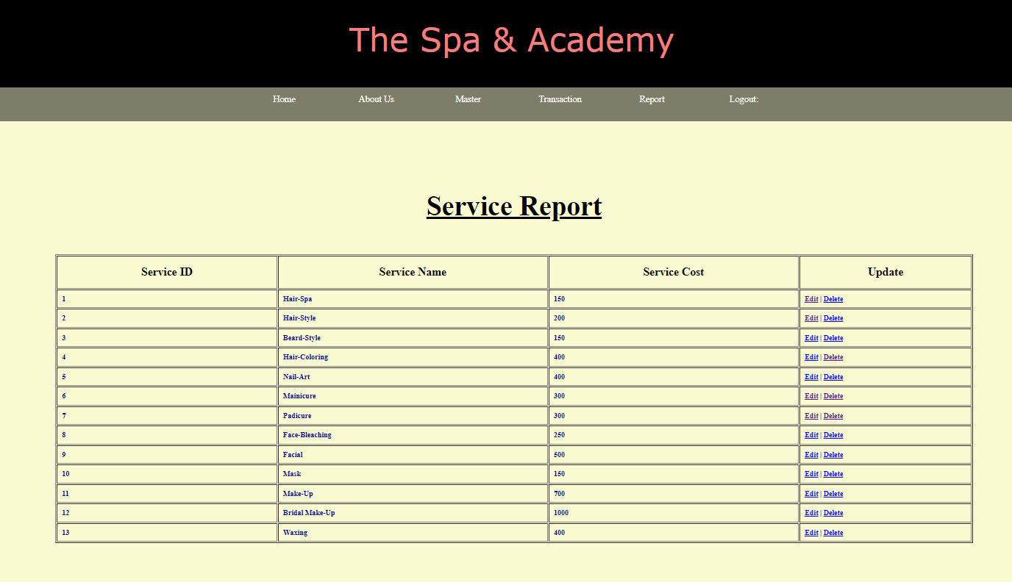

**Course Report:**

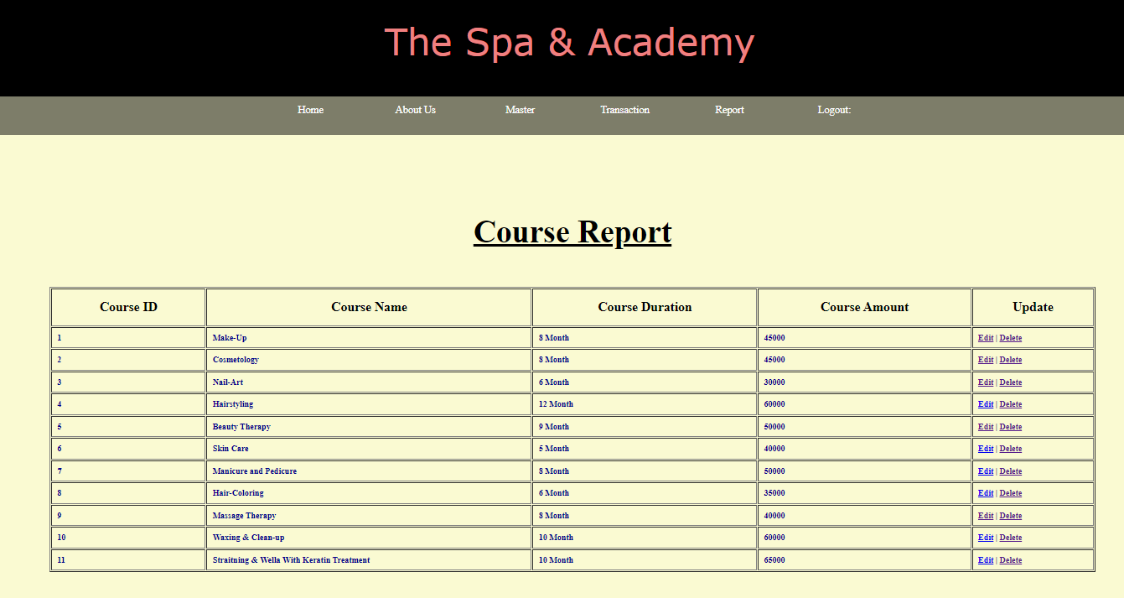

**Course Booking Report:**

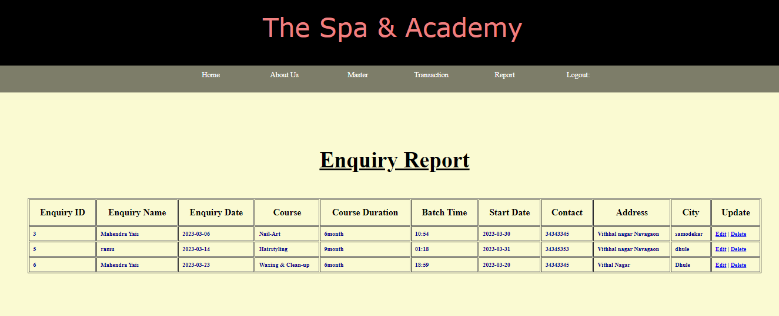

**Service Billing Report:**

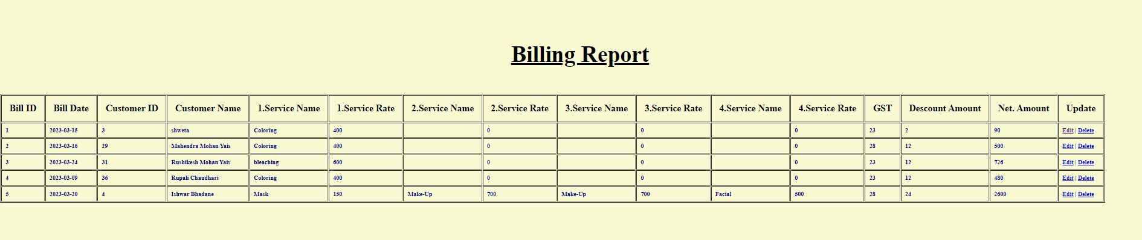

**Course Billing Report:**

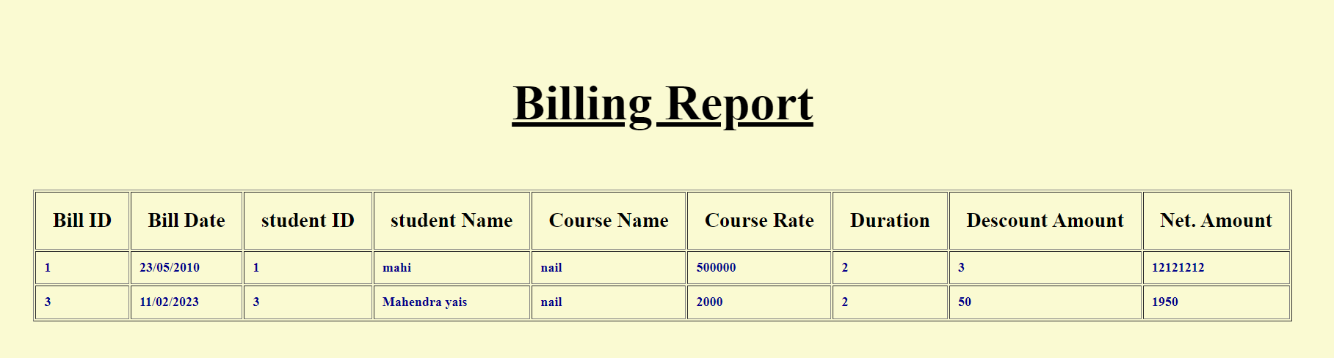

**Testing. Procedure and Implement:-**

**Chapter No 5**

**Testing Procedure**

Testing is the process of evaluating a system or its components with the intent to find that whether it satisfies the specified requirements or not. This activity results in the actual, expected and difference between their results. In simple words testing is executing a system in order to identify any gaps, errors or missing requirements in contrary to the actual desire or requirements.

According to ANSI/IEEE 1059 standard, Testing can be defined as "A process of analyzing a software item to detect the differences between existing and required conditions (that is defects/errors/bugs) and to evaluate the features of the software item"

**Software testing**

Software testing is the process used to measure the quality of developed computer software. Usually, quality is constrained to such topics as correctness, completeness, security, but can also include more technical requirements as described under the ISO standard ISO 9126, such as capability, reliability, efficiency, portability, maintainability, compatibility, and usability. Testing is a process of technical investigation, performed on behalf of stakeholders, that is intended to reveal quality-related information about the product with respect to the context in which it is intended to operate.

**Black box testing**

The technique of testing without having any knowledge of the interior workings of the application is Black Box testing. The tester is oblivious to the system architecture and does not have access to the source code. Typically, when performing a black box test, a tester will interact with the system's user interface by providing inputs and examining outputs without knowing how and where the inputs are worked upon.

**White box testing**

White box testing is the detailed investigation of internal logic and structure of the code. White box testing is also called glass testing or open box testing. In order to perform white box testing on an application, the tester needs to possess knowledge of the internal working of the code. The tester needs to have a look inside the source code and find out which unit/chunk of the code is behaving inappropriately.

**Grey Box Testing**

Grey Box testing is a technique to test the application with limited knowledge of the internal workings of an application. In software testing, the term "the more you know the better" carries a lot of weight when testing an application.

Mastering the domain of a system always gives the tester an edge over someone with limited domain knowledge. Unlike black box testing, where the testing only tests the application's user interface, in grey box testing, the testing has access to design document and the database. Having this knowledge, the tester is able to better prepare test data and test scenarios when making the test plan.

**Verification and Validation**

Software testing is used in association with verification and validation (V&V). Verification is the checking of or testing of items, including software, for conformance and consistency with an associated specification. Software testing is just one kind of verification, which also uses techniques such as reviews, inspections, and walkthroughs. Validation is the process of checking what has been specified is what the user actually wanted.

* Verification: I-lave we built the software right? (i.e. does it match the specification).
* Validation: Have we built the right software? (i.e. Is this what the customer wants?)

**Level of testing**

* **Unit testing**

This testing is performed by the developers before the setup is handed over to the testing team to formally execute the test cases. Unit testing is performed by the respective developers on the individual units of source code assigned areas. The developers use test data that is separate from the test data of the quality assurance team.

The goal of unit testing is to isolate each part of the program and show that individual partsare correct in terms of requirements and functionality.

* **Integration testing**

This is combined pans of an application to determine if they function correctly together is Integration testing. There are two methods of doing Integration Testing Bottom-up Integration testing and Top Integration testing.

Bottom-up integration testing begins with unit testing, followed by tests of progressively higher-level combinations of units called modules or builds.

Top-Down integration testing, the highest-level modules are tested first and progressively lower-level modules are tested after that. In a comprehensive software development environment, bottom-up testing is usually done first, followed by top-down testing.

• **Functional testing**

Functional testing is a type of black box testing that is based on the specifications of the software that is to be tested. The application is tested by providing input and then the results are examined that need to conform to the functionality it was intended for. Functional Testing of the software is conducted on a complete, integrated system to evaluate the system's compliance with its specified requirements. There are five steps that are involved when testing an application for functionality.

**Step** **I** - The determination of the functionality that the intended application meant to perform.

**Step Il** - The creation of test data based on the specifications of the application.

**Step Ill** - The output based on the test data and the specifications of the application. Step IV - The writing of Test Scenarios and the execution of test cases.

**Step V** —The comparison of actual and expected results based on the executed test cases.

An effective testing practice will see the above steps applied to the testing policies of every organization and hence it will make sure that the organization maintains the strictest of standards when it comes to software quality.

* **System integration testing**

Verifies that a system is integrated to any external or third party systems defined in the system requirements.

* **Acceptance testing**

This is arguably the most important type of testing, as it is conducted by the quality Assurance Team who will gauge whether the application meets the intended specifications and satisfies the client's requirement. The QA team will have a set of prewritten scenarios and test cases that will be used to test the application.

More ideas will be shared about the application and more tests can be performed on it to gauge its accuracy and the reasons why the project was initiated. Acceptance tests are not only intended to point out simple spelling mistakes, cosmetic errors, or interface gaps, but also to point out any bugs in the application that will result in system crashes or major errors in the application.

By performing acceptance tests on an application, the testing team will deduce how the application will perform in production. There are also legal and contractual requirements for acceptance of the system.

* **Alpha testing**

This test is the first stage of testing and will be performed amongst the teams (developer and QA teams). Unit testing, integration testing and system testing when combined together is known as alpha testing. During this phase, the following aspects will be tested in the application:

* Spelling Mistakes
* Broken Links
* Cloudy Directions

The Application will be tested on machines with the lowest specification to test loading times and any latency problems.

* **Beta testing**

This test is performed after alpha testing has been successfully performed. In beta testing, a sample of the intended audience tests the application. Beta testing is also known as pre-release testing. Beta test versions of software are ideally distributed to a wide audience on the Web, partly to give the program a "real-world" test and partly to provide a preview of the next release.

**Chapter No 6**

**Introduction to PHP and MYSQL**

**Introduction of PHP**

PHP is a widely used, general-purpose scripting language that was originally designed for web development, to produce dynamic web pages. It can be embedded into HTML and generally runs on a web server, which needs to be configured to process PHP code and create web page content from it. It can be deployed on most web servers and on almost every operating system and platform free of charge. PHP is installed on over 20 million websites and 1 million web servers.

PHP was originally created by Rasmus Lerdorf in 1994 and has been in continuous development ever since. The main implementation of PHP is now produced by The PHP Group and serves as the de facto standard for PHP as there is no formal specification. PHP is free software released under the PHP License, which is incompatible with the GNU General Public License (GPL) because of restrictions on the use of the tern PHP. PHP has evolved to include a command line interface capability and can also be used in standalone graphical applications.

PHP originally stood for Personal Home Page. It began in 1994 as a set of Common Gateway Interface binaries written in the C programming language by the Danish/Greenlandic programmer Rasmus Lerdorf. initially created these Personal Home Page Tools to replace a small set of Perl scripts he had been using to maintain his personal homepage. The tools were used to perform tasks such as displaying his resume and recording how much traffic his page was receiving. He combined these binaries with his Form Interpreter to create PHP/FI, which had more functionality. PHP/FI included a larger implementation for the C programming language and could communicate with databases, enabling the building of simple, dynamic web applications. Lerdorf released PHP publicly on June 8, 1995 to accelerate bug location and improve the code. This release was named PHP version 2 and already had the basic functionality that PHP has today. This included Perl-like variables, form handling, and the ability to embed HTML. The syntax was similar to Perl but was more limited, simpler, and less consistent.

Zeev Suraski and Andi Gutmans, two developers at the Technion 11T, rewrote the parser in 1997 and formed the base of PHP 3, changing the language's name to the recursive initialism PHP: Hypertext Preprocessor. The development team officially released PHP/Fl 2 in November 1997 after months of beta testing. Afterwards, public testing of PHP 3 began, and the official launch came in June 1998. Suraski and Gutmans then started a new rewrite of PHP's core, producing the Zend Engine in 1999. They also founded Zend Technologies in Ramat Gan, Israel.

On May 22, 2000, PHP 4, powered by the Zend Engine 1.0, was released. As of August, 2008 this branch is up to version 4.4.9. PHP 4 is no longer underdevelopment nor will any security updates be released. On July 13, 2004, PHP 5 was released, powered by the new Zend Engine Il. PHP 5 included new features such as improved support for object oriented programming, the PHP Data Objects extension (which defines a lightweight and consistent interface for accessing databases), and numerous performance enhancements. In 2008, PHP 5 became the only stable version under development. Late static binding has been missing from PHP and has been added in version 5.3. PHP 6 is under development alongside PHP 5. Major changes include the removal of register_ globals magic quotes, and safe mode. The reason for the removals was that register_globals had given way to security holes, and magic quotes had an unpredictable nature, and was best avoided.

Many high-profile open-source projects ceased to support PHP 4 in new code as of February 5, 2008, because of the GoPHP5 initiative, provided by a consortium of PHP developers promoting the transition from PHP 4 to PHP 5. PHP currently does not have native support for Unicode or multibyte strings; Unicode support will be included in PHP 6 and will allow strings as well as class, method and function names to contain non-ASCII characters. lt runs in both 32-bit and 64-bit environments, but on Windows the only official distribution is 32bit, requiring Windows 32-bit compatibility mode to be enabled while using IIS in a 64-bit Windows environment. As of PHP 5.3.0, experimental x64 bit versions are available.

PHP is a general-purpose scripting language that is especially suited for web development. PHP generally runs on a web server. Any PHP code in a requested file is executed by the PHP runtime, usually to create dynamic web page content. It can also be used for command-line scripting and client-side GUI applications. PHP can be deployed on most web servers, many operating systems and platforms, and can be used with many relational database management systems. It is available free of charge, and the PHP Group provides the complete source code for users to build, customize and extend for their own use.

PHP primarily acts as a filter. taking input from a file or stream containing text and/or PNP instructions and outputs another stream of data; most commonly the output will be HINL. PIIP now focuses mainly on server-side scripting. and it is similar to other server-side scripting languages that provide dynamic content from a web server to a client, such as Microsoft's Active Server Pages, Sun Microsystems' JavaServerPages, and mod_perl. PHP has also attracted the development of many frameworks that provide building blocks and a design structure to promote rapid application development (RAD).

**Introduction of MYSQL**

MySQL is a relational database management system (RDBMS) which has more than 6 million installations. MySQL stands for "My Structured Query Language". The program runs as a server providing multi-user access to a number of databases. The project's source code is available under terms of the GNU General Public License, as well as under a variety of proprietary agreements. MySQL is owned and sponsored by a single for-profit firm, the Swedish company MySQL AB, now a subsidiary of Sun Microsystems, which holds the copyright to most of the codebase. MySQL is commonly used by free software projects which require a full-featured database management system, such as WordPress, phpBB and other software built on the LAMP software stack. It is also used in very high-scale World Wide Web products including Google and Facebook.

Uses MySQL is used in web applications and acts as the database component of the LAMP software stack. Its popularity for use with web applications is closely tied to the popularity of PHP, which is often combined with MySQL. Several high-traffic web sites (including Flickr, Facebook, Wikipedia, Google (though not for searches), Nokia, Auctionmarts and YouTube) use MySQL for data storage and logging of user data.

The MySQL Administrator in Linux. MySQL is written in C and C++. The SQL parser uses yacc and a home-brewed lexer, sql_lex.cc. MySQL works on many different system platforms, including AIX, BSDi, FreeBSD, HP-UX, i5/0S, Linux, Mac OS X, NetBSD, Novell NetWare, OpenBSD, OpenSolaris, eComStation, OS/2 Warp, QNX, IRIX, Solaris, Synbian, SunOS, SCO OpenServer, SCO UnixWare, Sanos, Tru64 and Microsoft Windows. A port of MySQL to OpenVMS is also available.

Libraries for accessing MySQL databases are available in all major programming languages with language-specific APIs. In addition, an ODBC interface called MyODBC allows additional programming languages that support the ODBC interface to communicate with a MySQL database, such as ASP or ColdFusion. The MySQL server and official libraries are mostly implemented in ANSI C/ANSI C++. To administer MySQL databases one can use the included command-line tool (commands: MySQL and mysqladmin). Also downloadable from the MySQL site are GUI administration tools: MySQL Administrator, MySQL Migration Toolkit and MySQL Query Browser. The GUI tools are now included in one package called MySQL GUI Tools.

In addition to the above-mentioned tools developed by MySQL AB, there are several other commercial and non-commercial tools available. Examples include Navicat Free Lite Edition or SQLyog Community Edition, they are free desktop based GUI tools, and phpMyAdmin, a free Web-based administration interface implemented in PHP.

There are 3 types of MySQL Server Compilations for Enterprise and Community users:

* Standard: The MySQL-Standard binaries are recommended for most users, and include the InnoDB storage engine.
* Max: (not MaxDB, which is a cooperation with SAP AG) is mysqld-max Extended MySQL Server. The MySQL-Max binaries include additional features that may not have been as extensively tested or are not required for general usage.
* The MySQL: Debug binaries have been compiled with extra debug information, and are not intended for production use, because the included debugging code may cause reduced performance.

Beginning with MySQL 5.1, MySQL AB has stopped providing these different package variants. There will only be one MySQL server package, which includes a mysqldbinary with all functionality and storage engines enabled. Instead of providing a separate debug package, a server binary with extended debugging information is also included in the standard package.

**Front End and Back End**

**Front-End:**

Web Pages using PHP, HTML and JavaScript.

**HTML —** It is used to generate web page. HTML, an initialism of Hypertext Markup Language, is the predominant markup language for web pages. It provides a means to describe the structure of text-based information in a document — by denoting certain text as headings, paragraphs, lists, and so on.

• **JAVASCRIPT —** It is used for checking User information before sending to JavaScript is a scripting language most often used for client-side web development. It is a dynamic, weakly typed, prototype-based language with first-class functions. Currently, "JavaScript" is an implementation ofthe ECMA Script standard.

• **PHP-** Php is a Technology that lets you mix regular, static HTML with dynamicallygenerated HTML. Many Web pages that are built by CGI programs are mostly static, with the dynamic part limited to a few small locations. But most CGI variations, including servlets, make you generate the entire page via your program, even though most of it is always the same.

* **Backend:**

**My SQL** is a relational database management system (RDBMS) which has more than 6 million installations. MySQL stands for 'My Structured Query Language". The program runs as a server providing multi-user access to a number of databases.

**Xampp** Apache is a web container, or application server developed at the Apache Software Foundation (ASF). It adds tools for configuration and management but can also be configured by editing configuration files that are normally XML-formatted. Apache includes its own internal HTTP server.

**Chapter No 7**

**Scope of Future Enhancement**

**Future Scope :**

The project has a wide scope. Our project mainly helps in improving productivity and makes use of utilization of resources. is no duplication of work as this was not the case when done manually. This it reduces labor and increases morale. system intends user friendly operations which may resolve ambiguity. The project is a total management and informative system, which provides the up- to-date information of all the employee in the company. Our system also help the college to overcome the difficulty in keeping records of hundreds of sale and searching for a product. It helps in effective and timely utilization of resources. The project facilitates user friendly, reliable and fast management system. They need not concentrate on record keeping. The company can maintain computerized records thus reducing paper work, time and money.

**Scope for Future Enhancement :**

• The application developed is very and scalable. Some other features such easier comprehensive faster application development and other accepts are also included.

• In some template can be created from various policies for the organization and government rules proposed enhancement we can provided.

• We will include advance account configure.

• We will include data import and export to the our module.

• In this system we use statistical and growth report for output so in future we want to use crystal report for better output and formatting.

After the implementation of the system they were satisfied with our work they assured us that whenever they will required any need of any other module. In the future they would prefer us.

• They were highly satisfied with the user training as well as documentation prepared by us.

**Chapter No 8**

**Conclusion and**

**Suggestion**

**Conclusion:**

Since we are entering details of the customer electronically in the" Spa & Academy Management System", data will be secured. Using this application we can retrieve customer’s history with a single click. Thus processing information will be faster. It guarantees accurate maintenance of customer details. It easily reduces the book keeping task and thus reduces the human effort and increases accuracy speed.

**Strength of System:**

• Platform independent

• User friendly

• Graphical user interface

• Easy to customize

• System administration module provides rights to user to create new user, to assign new roles to user, to assign new privileges to user.

• Multiple users can access system simultaneously without loss of data.

• Both local and dollar currencies are used.

• Due to thin driver connectivity speed is improved.

• User can post operation charges to ledger account.

**Limitations of System:**

• The system depends somewhat on the network speed.

• There is need to improve presentation layer.

• Pure object orientation is not implemented.

**Chapter No 9**

**Bibliography &**

**Refences**

**Books:**

* .PHP and MySql by W Jason Gilmore, A press Publication
* Fundamentals of Software Engineering by RAJIB MALL
* PHP And MySQL Development by Laura Thomson And Luke Welling.
* Learning PHP, MySQL And JavaScript by Robin Nixon.
* The Complete Reference- MySQL by Vikram Vaswami.
* The Complete Reference HTML & CSS by Thomas Powell